## Lab 10-01: Estimate and Compare Workload Costs by using the Pricing Calculator

### Service Introduction

Ecomify, a fast-growing e-commerce platform, experienced significant traffic surges during peak season, leading to performance bottlenecks and concerns about escalating cloud costs. They lacked transparency in their Azure spending and struggled to compare cost-effectiveness across different configurations for their e-commerce platform.

### Problem

Ecomify's pay-as-you-go model meant fluctuating cloud bills, making it difficult to budget and optimize spending. They lacked insight into resource utilization and cost drivers. Ecomify needed a solution to handle peak traffic without incurring excessive costs, but scaling resources without understanding potential expenses was risky.

### Solution

Ecomify's success story demonstrates the transformative power of Azure Pricing Calculator and TCO for cloud-based businesses seeking to optimize costs and achieve financial clarity. By leveraging these tools, Ecomify achieved cost transparency, improved decision-making, and gained confidence in its cloud scalability, letting it focus on its core business and growth.

This lab demonstrates how to estimate the Total Cost of Ownership with the Azure TCO calculator.

1. Navigate to the web browser and go to the Total Cost of Ownership website.

https://azure.microsoft.com/en-us/pricing/tco/calculator/

1. The default page of the TCO calculator will appear.
2. Click on “**Start assessment.”**

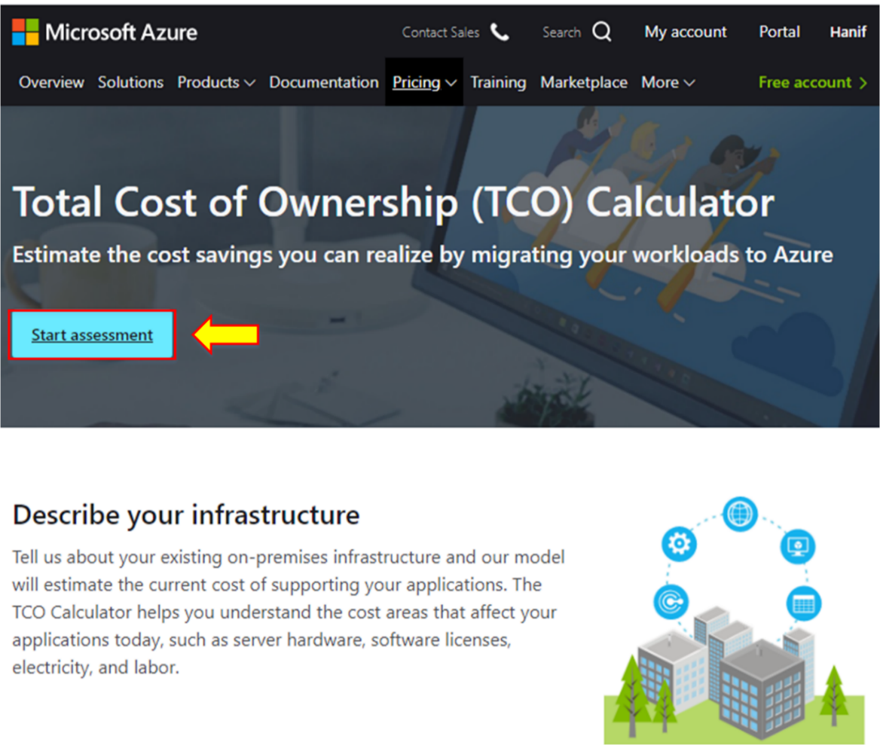

1. There are three steps to estimate cost savings. To estimate any cost, you must first define the workload weightage.

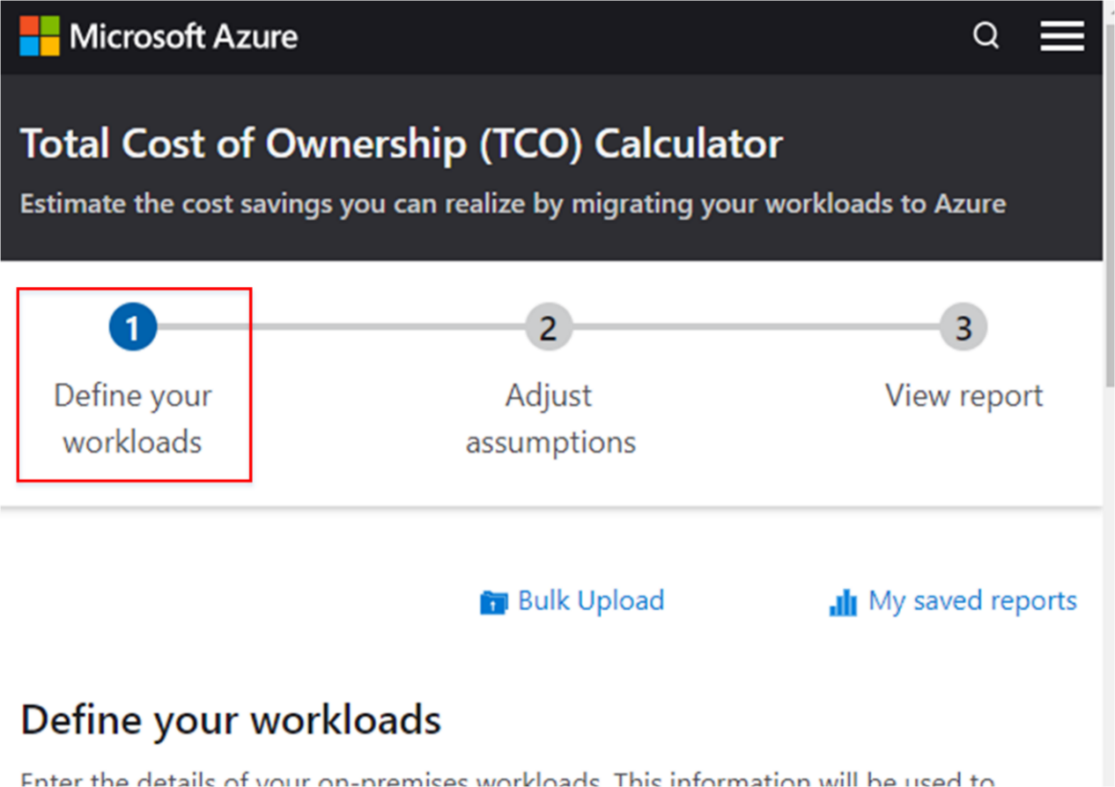

1. To define the workload, click on **+Add server workload**, **+Add database**, and **+Add storage**.

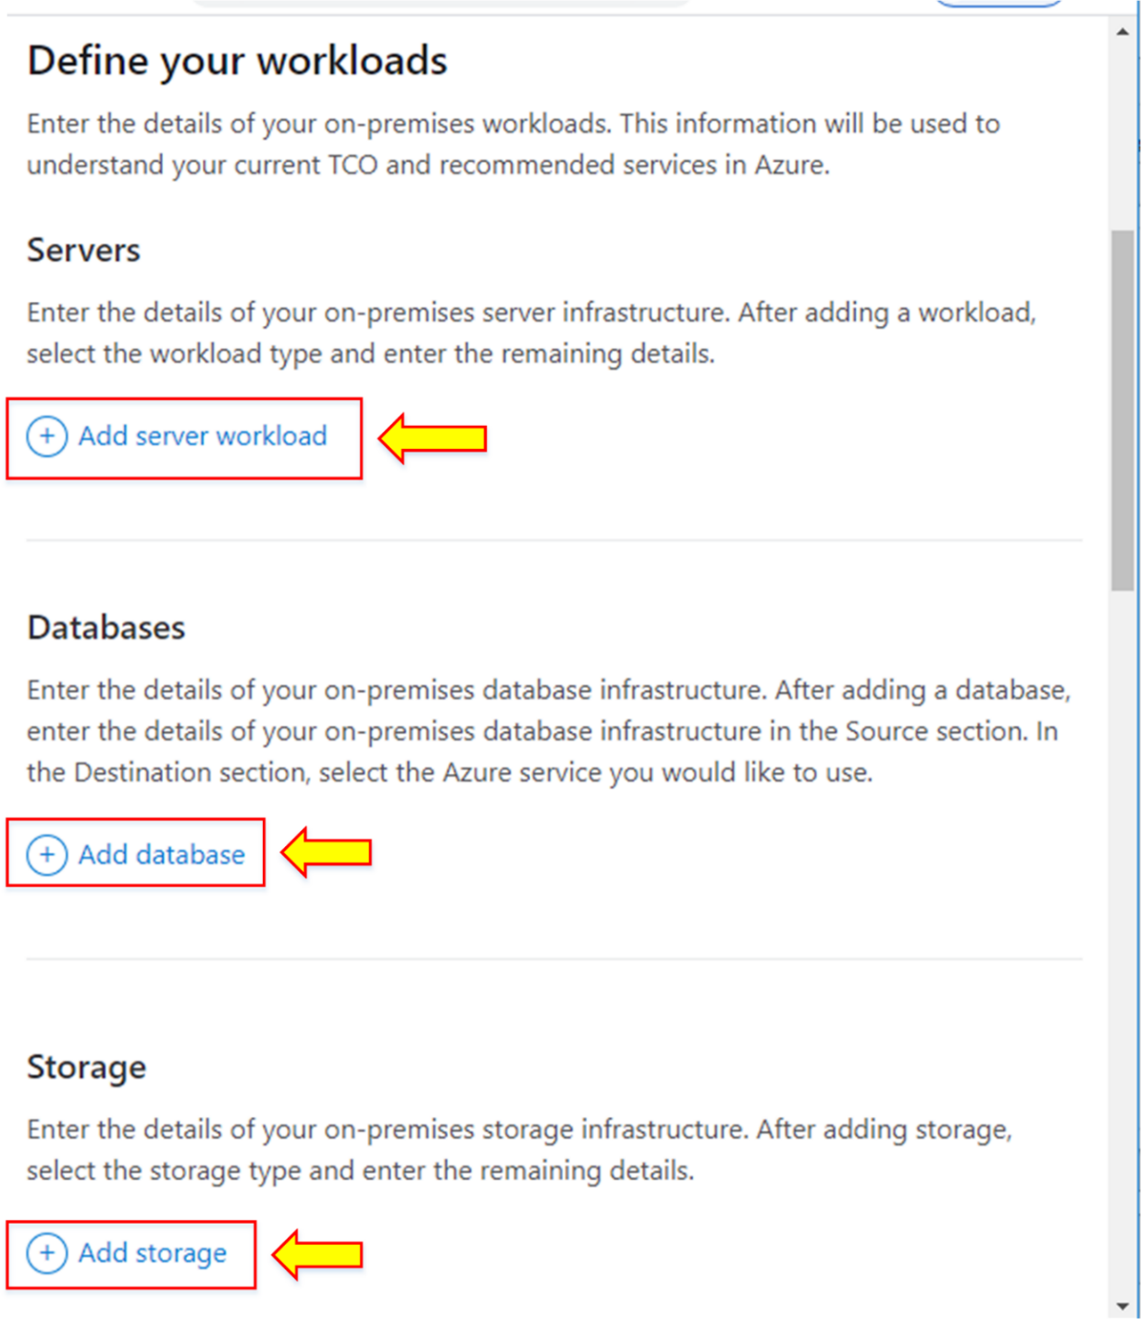

**Note:** Enter the details of the current on-premises server infrastructure, database infrastructure, storage infrastructure, and network bandwidth.

1. After defining the workload, click on **Next**.

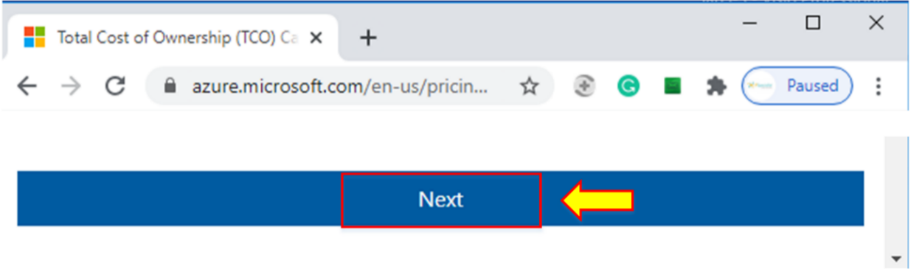

1. After defining the workload, the next step is **“Adjust assumptions.”**
2. Select the currency of your choice.

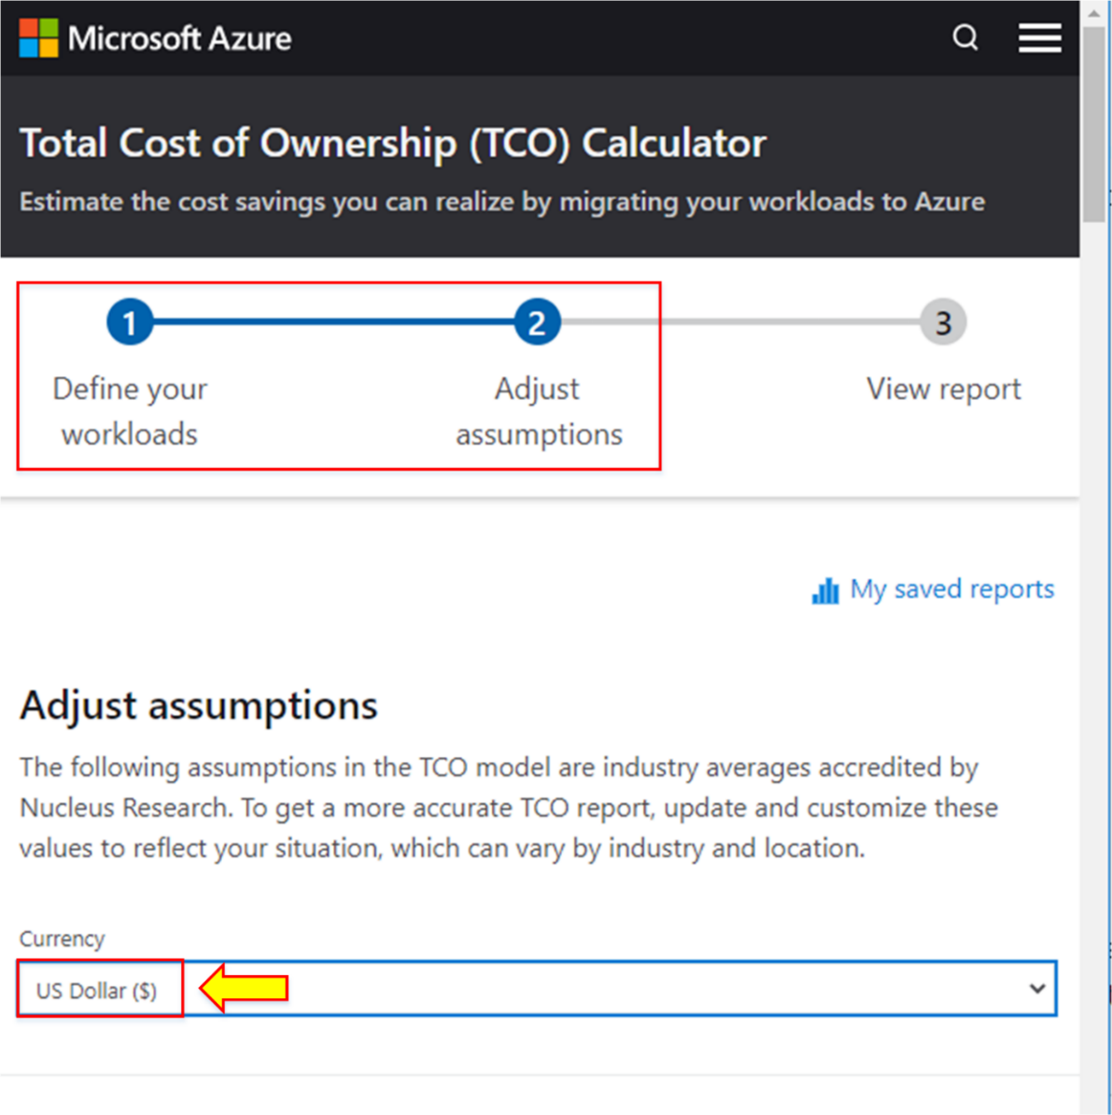

1. Select other assumptions according to your choice. Click on **Next**.

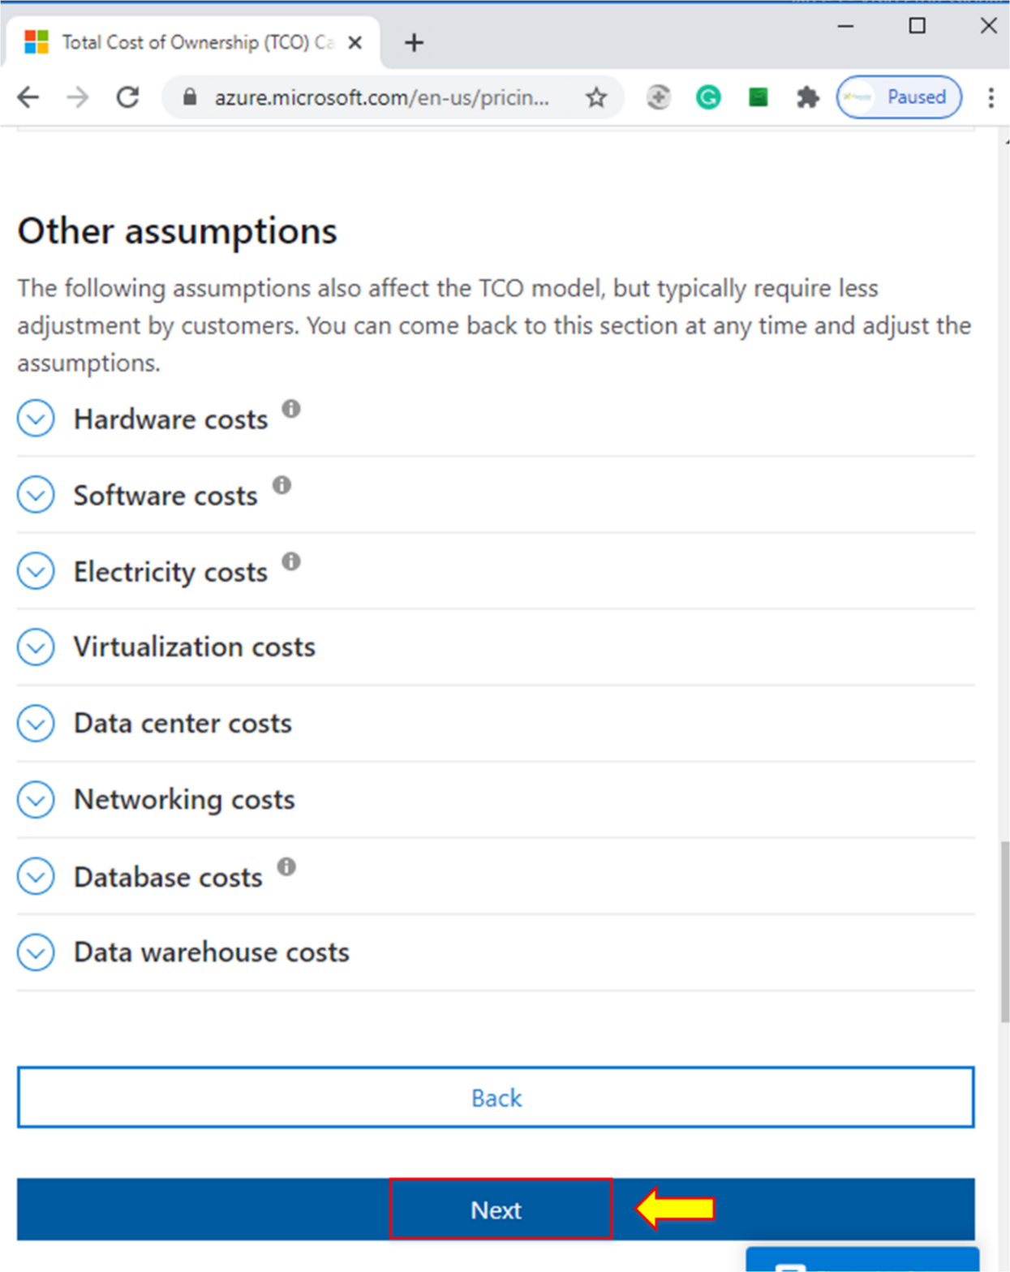

1. After defining the workload and adjusting assumptions, the last step is to view the report.

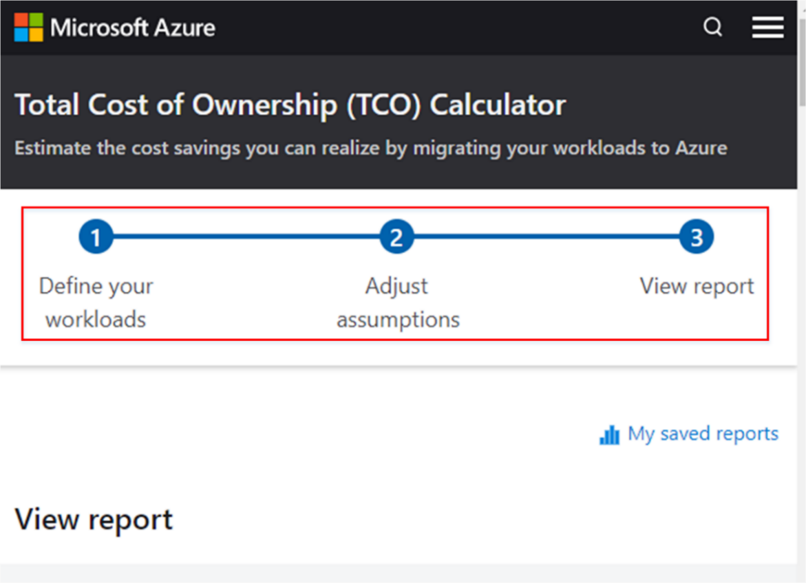

1. You will see the details of the costs in graph form, as shown below:

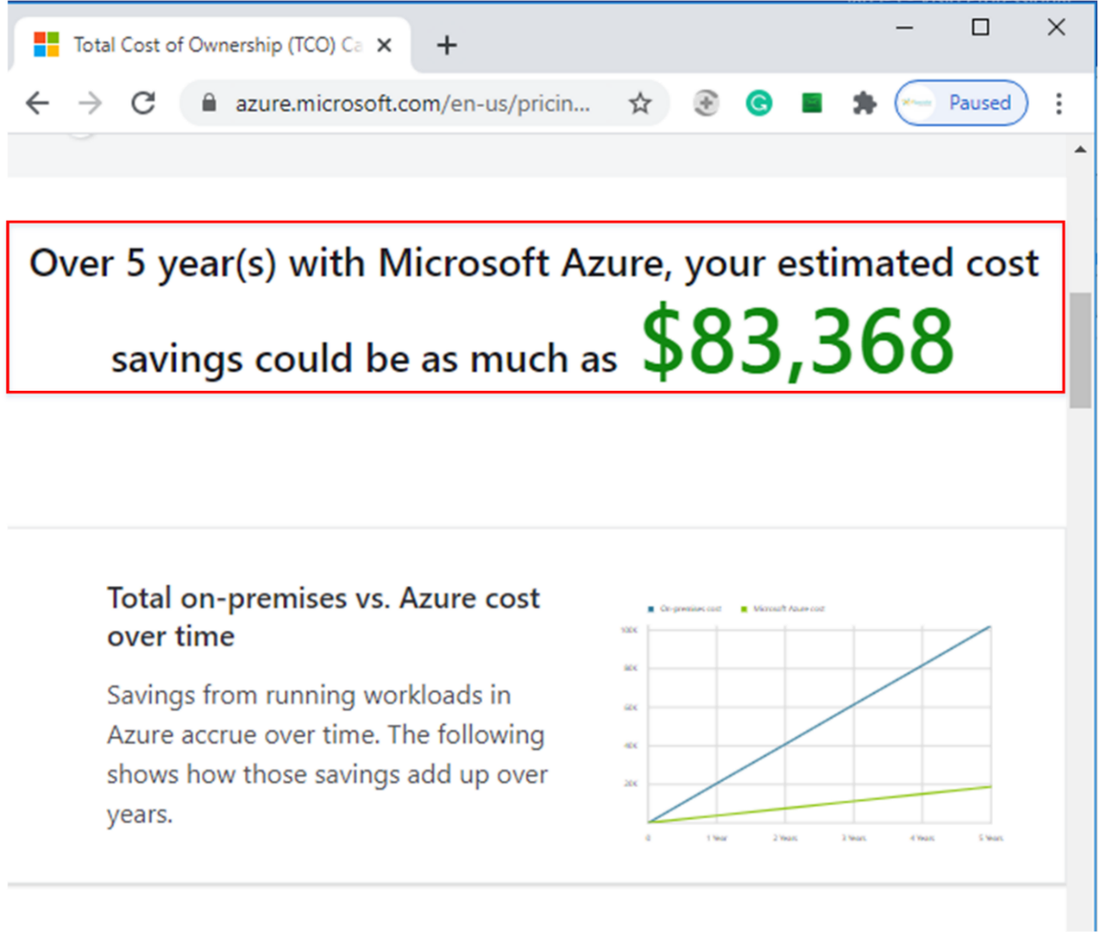

## Lab 10-02: Using the Pricing Calculator

### Service Introduction

The Azure Pricing Calculator is a valuable tool for organizations and individuals looking to estimate and understand the costs associated with deploying resources and services in the Microsoft Azure cloud. Accessible through the Azure portal, the calculator allows users to select and configure various Azure services, regions, and deployment options to generate accurate cost projections. Users can input details such as the number of virtual machines, storage capacity, and network resources to tailor the estimate to their specific requirements. Additionally, the Azure Pricing Calculator provides visibility into potential cost savings through reserved instances or specific pricing tiers. This tool empowers users to make informed decisions about resource provisioning and optimize their Azure spending based on their unique needs and budget constraints, contributing to a cost-effective and efficient cloud deployment strategy.

### Problem

An organization is planning to upgrade its infrastructure with Azure services but wants to know the estimated cost for requesting the Virtual Machine and Azure Function service.

### Solution

Microsoft Azure provides a free pricing calculator to estimate the cost of any services. You select the service and add the features you want to find the estimated result of the cost that you can download in the form of an Excel Sheet, which can be useful for decision-making.

|  |
| --- |
| 1. Open a browser and go to the Azure pricing calculator using the given URL.   <https://azure.microsoft.com/en-au/pricing/calculator/>     1. Click on the **“Virtual Machines.”**      1. Here, you can see the display of Virtual Machines. 2. Configure Virtual Machines as needed. 3. Select the Region, OS, Tier, and Instance.      1. On the billing options, select the number of Virtual Machines and the number of hours for utilizing this VM. 2. You can see the estimated cost of 1 VM with 1 hour of utilization.      1. Now, click on “**Azure Functions”** to add functions.      1. Configure Azure functions by selecting regions, memory size, execution time, and number of executions. 2. You can see the estimated cost for 4 million requests in 100 seconds, as shown below.      1. Select the support level that charges 100 USD. 2. See the total estimated cost of all the added services. 3. Save and export the result. |